CS-23334 FUNDAMENTALS OF DATA SCIENCE
ASHWIN C 240701058

Experiment 6 Date: 04.09.2025

6. Experiment to understand EDA-Quantitative and Qualitative analysis.

Aim:
To conduct an experiment to understand EDA- Quantitaive and Qualitative Analysis

Description:
To understand importance of EDA Analysis

Algorithm:
Step 1: Identify Quantitative and Qualitative Features
Step 2: Perform Summary Statistics and Distribution Analysis
Step 3: Visualize Quantitative Data (Histograms, Box Plots, Correlation)
Step 4: Visualize Qualitative Data (Bar Charts, Pie Charts, Frequency Tables)
Step 5: Interpret Patterns, Relationships, and Anomalies

Code With Output: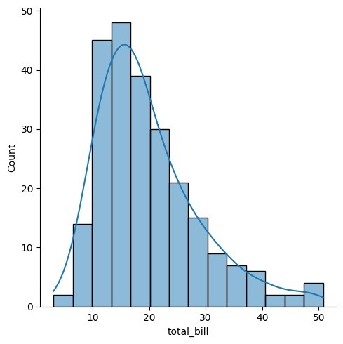
import seaborn as sns import pandas as pd import numpy as np
import matplotlib.pyplot as plt
%matplotlib inline
tips=sns.load_dataset('tips') tips.head()
total_bill tip sex smoker day time size 0 16.99 1.01 Female No Sun Dinner 2
- 10.34 1.66 Male No Sun Dinner 3
- 21.01 3.50 Male No Sun Dinner 3
- 23.68 3.31 Male No Sun Dinner 2
- 24.59 3.61 Female No Sun Dinner 4
sns.displot(tips.total_bill,kde=True)
<seaborn.axisgrid.FacetGrid at 0x15b17dfb770>
sns.displot(tips.total_bill,kde=False)
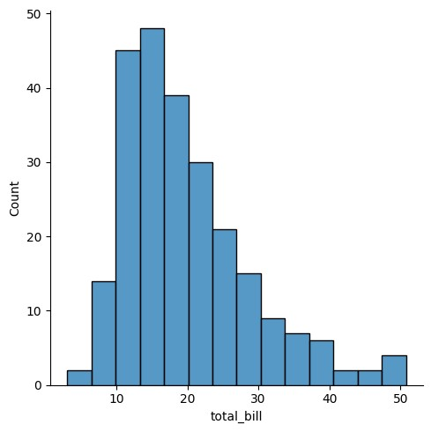
<
seaborn.axisgrid.FacetGrid at 0x15b17fb
2350>
sns.jointplot(x=tips.tip,y=tips.total_bill)
<seaborn.axisgrid.JointGrid at 0x15b1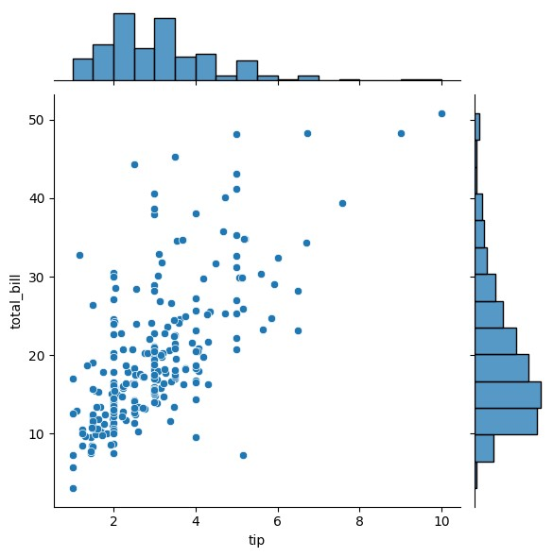7dfb620>

sns.jointplot(x=tips.tip,y=tips.total_bill,kind="reg")
<seaborn.axisgrid.JointGrid at 0x15b1d1a7110>
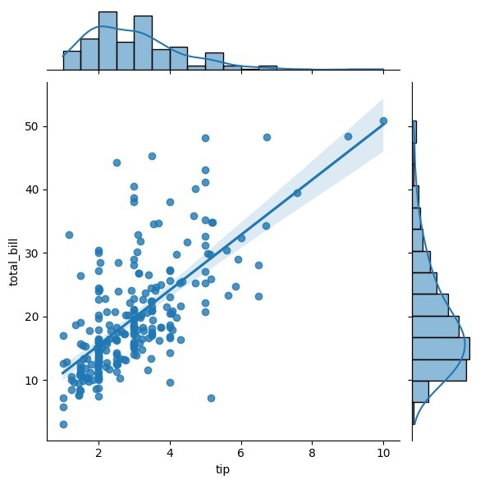
sns.jointplot(x=tips.tip,y=tips.total_bill,kind="hex")
<seaborn.axisgrid.JointGrid at 0x15b1d318910>
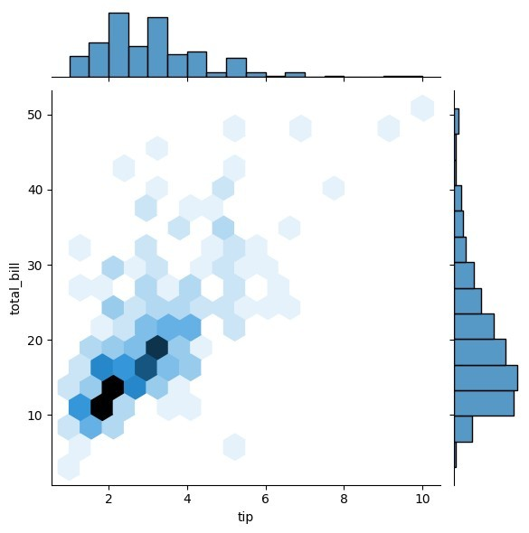
sns.pairplot(tips) <seaborn.axisgrid.PairGrid at 0x15b17f07cb0>
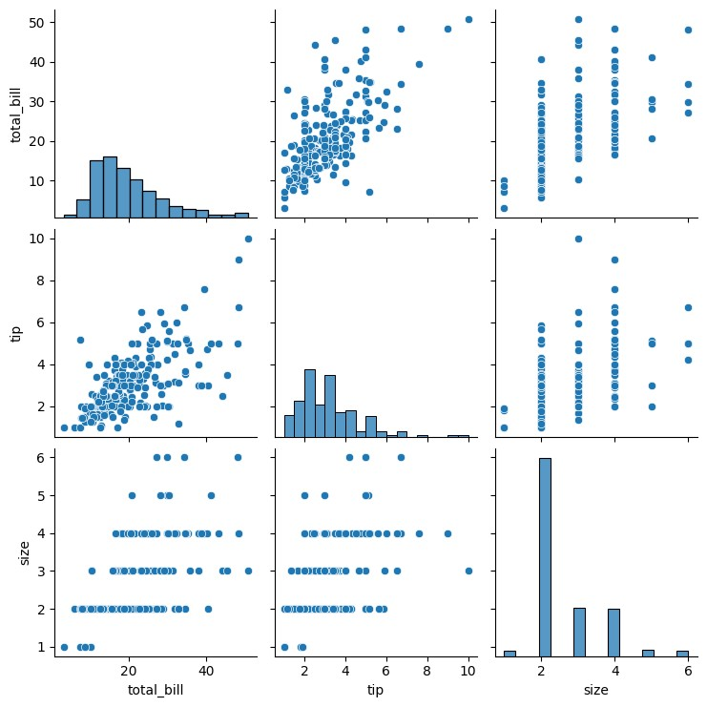
tips.time.value_counts()
time
Dinner 176
Lunch 68
Name: count, dtype: int64
sns.pairplot(tips,hue='time')
<seaborn.axisgrid.PairGrid at 0x15b1d93c2d0>
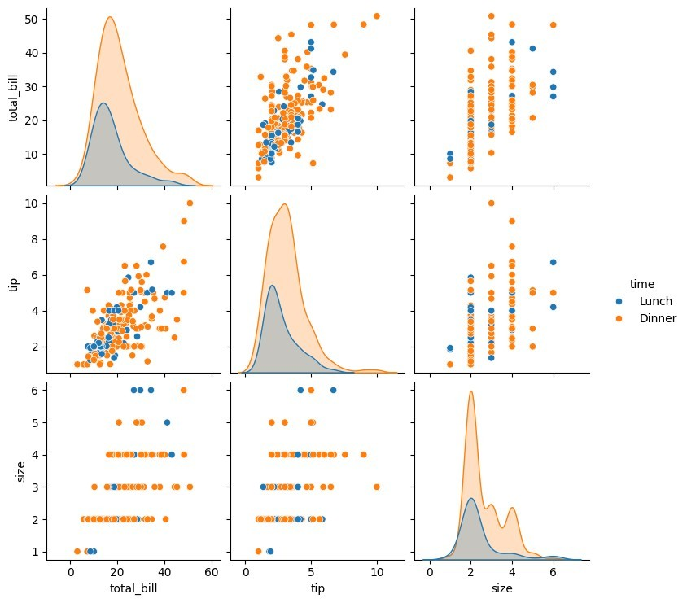

sns.pairplot(tips,hue='day')
<seaborn.axisgrid.PairGrid at 0x15b1dda07d0>
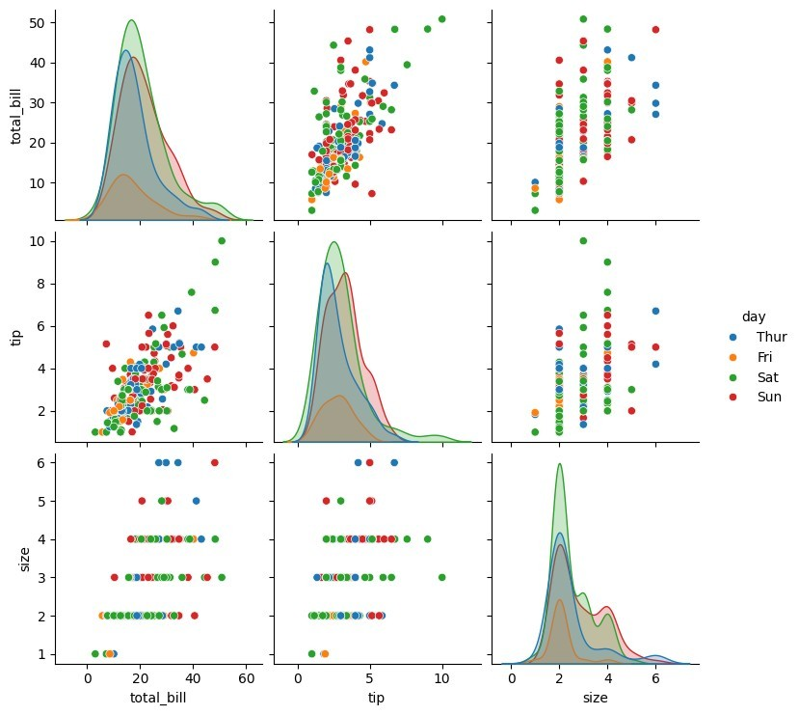
sns.heatmap(tips.corr(numeric_only=True),annot=True)
<Axes: >
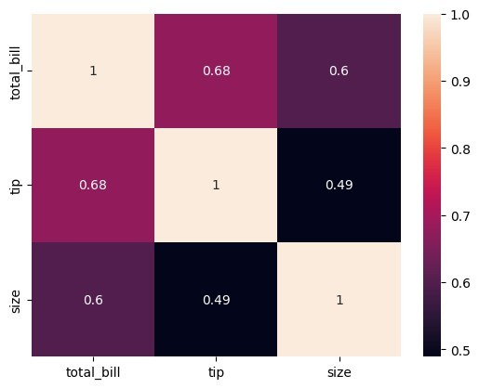
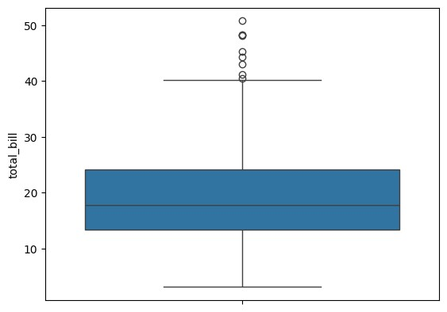
sns.boxplot(tips.total_bill) <Axes: ylabel='total_bill'> sns.countplot(tips.day)
<Axes: xlabel='count', ylabel='day'>

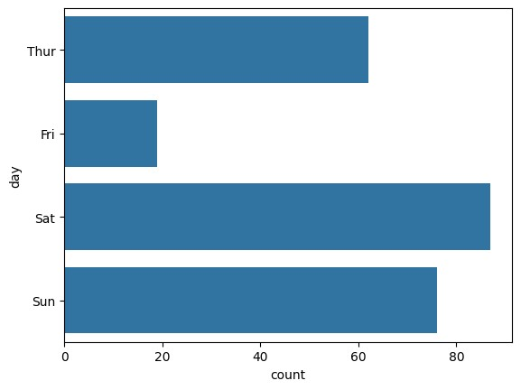
sns.countplot(tips.sex) <Axes: xlabel='count', ylabel='sex'>
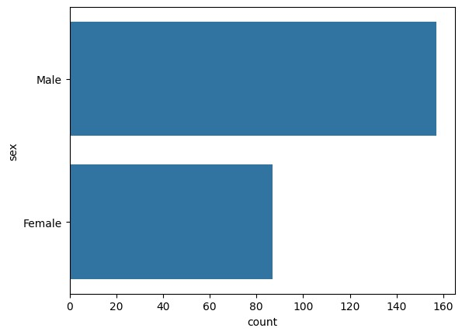
tips.sex.value_counts().plot(kind='bar')
<Axes: xlabel='sex'>
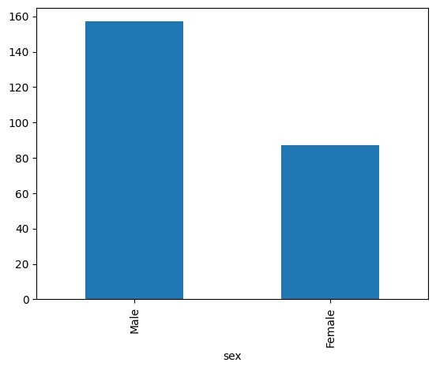
tips.sex.value_counts().plot(kind='pie')
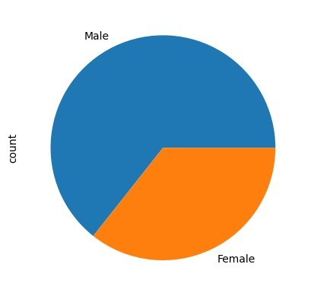
<Axes: ylabel='count'> tips.sex.value_counts().plot(kind='bar')
<Axes: xlabel='sex'>
sns.countplot(tips[tips.time=='Dinner']['day'])
<Axes: xlabel='count', ylabel='day'>

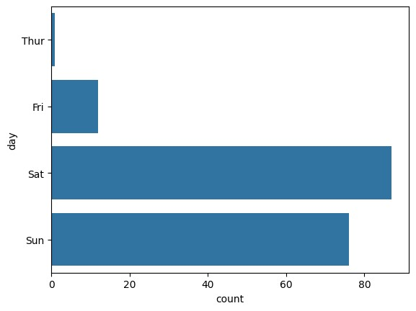
Result:

Thus Python Program to understand EDSA -Analysis was executed Successfully

